Filling with Average or Median

Definition
# Source: AI Source: Provided by: [Data Path: Persons Table -> ID Column: 1, Name_En Column: Motasem Essam] -> From: [Chatgpt (GPT‑5 Mini)] on [12/10/2025]
Filling with Average or Median is a method used in data cleaning where missing numerical values are replaced with the average (mean) or the median of the existing data.
- This helps maintain the overall distribution of the dataset.
- It is commonly used in numerical datasets such as scores, sales, or measurements.
Key idea:
It is like estimating a missing value based on the typical values of similar records.

Characteristics
# Source: AI Source: Provided by: [Data Path: Persons Table -> ID Column: 1, Name_En Column: Motasem Essam] -> From: [Chatgpt (GPT‑5 Mini)] on [12/10/2025]
- Used mainly for numerical data
- Replaces missing values with statistical measures (mean or median)
- Helps maintain dataset size and structure
- Easy to apply using spreadsheets, databases, or statistical software
- Often used during data preprocessing before analysis or machine learning

Example
# Source: AI Source: Provided by: [Data Path: Persons Table -> ID Column: 1, Name_En Column: Motasem Essam] -> From: [Chatgpt (GPT‑5 Mini)] on [12/10/2025]
Original dataset:
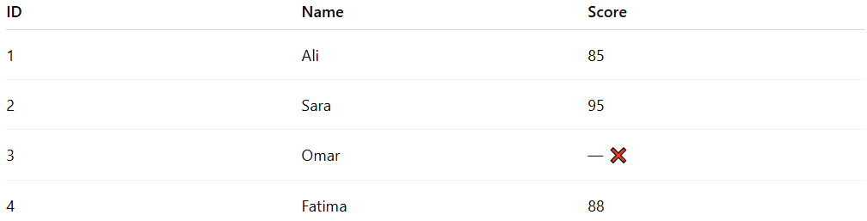
ID | Name | Score
1 | Ali | 85
2 | Sara | 95
3 | Omar | — ❌
4 | Fatima | 88
Step 1: Calculate the Average (Mean)
Average = (85 + 95 + 88) / 3 = 89.33
Step 2: Replace the Missing Value
Cleaned dataset:
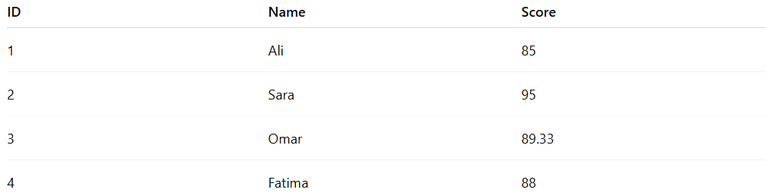
ID | Name | Score
1 | Ali | 85
2 | Sara | 95
3 | Omar | 89.33
4 | Fatima | 88

Using Median Instead
# Source: AI Source: Provided by: [Data Path: Persons Table -> ID Column: 1, Name_En Column: Motasem Essam] -> From: [Chatgpt (GPT‑5 Mini)] on [12/10/2025]
Scores: 85, 88, 95
Median = 88
Replace missing value:
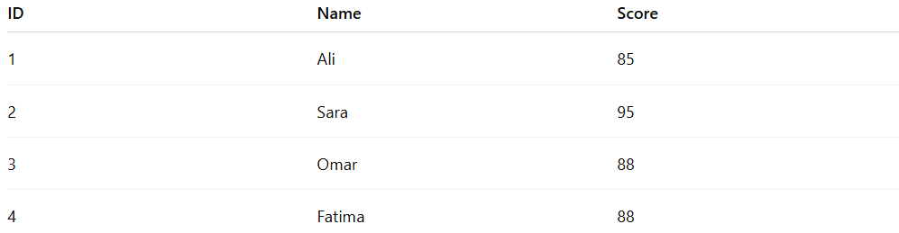
ID | Name | Score
1 | Ali | 85
2 | Sara | 95
3 | Omar | 88
4 | Fatima | 88

Example Section
# Source: AI Source: Provided by: [Data Path: Persons Table -> ID Column: 1, Name_En Column: Motasem Essam] -> From: [Chatgpt (GPT‑5 Mini)] on [12/10/2025]
A teacher analyzes student scores, but one score is missing.
Before cleaning:
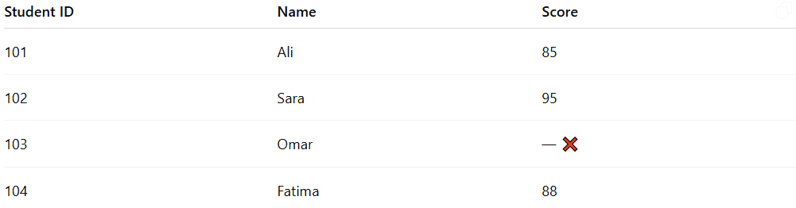
Student ID | Name | Score
101 | Ali | 85
102 | Sara | 95
103 | Omar | — ❌
104 | Fatima | 88
Cleaning process:
- Calculate the average score of available students.
- Replace Omar’s missing score with the calculated value.
After cleaning:
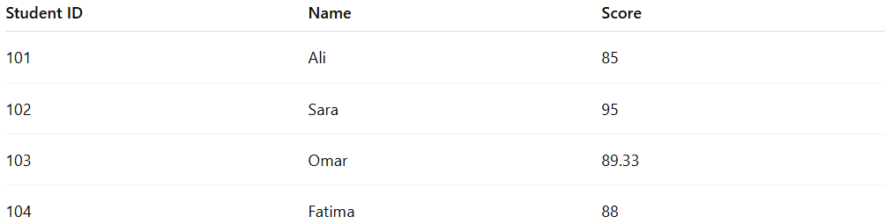
Student ID | Name | Score
101 | Ali | 85
102 | Sara | 95
103 | Omar | 89.33
104 | Fatima | 88
This allows the dataset to remain complete and suitable for analysis.

Advantages
# Source: AI Source: Provided by: [Data Path: Persons Table -> ID Column: 1, Name_En Column: Motasem Essam] -> From: [Chatgpt (GPT‑5 Mini)] on [12/10/2025]
- Maintains dataset size without removing records
- Easy to implement and understand
- Preserves overall statistical properties of the data
- Useful for large datasets with few missing values

Disadvantages
# Source: AI Source: Provided by: [Data Path: Persons Table -> ID Column: 1, Name_En Column: Motasem Essam] -> From: [Chatgpt (GPT‑5 Mini)] on [12/10/2025]
- Replaced values are estimates and may not reflect real data
- Using the mean may distort results if extreme values exist
- Can reduce data variability
- Not suitable for categorical or non-numeric data

